SME Finder Widget Help.
Introduction to the SME Finder: SME Finder is the Subject Matter Expert Finder. This widget allows xx staff to search databases for the identification of staff related to a specific intelligence area. i.e. The widget helps find Subject Matter Experts.
User Flow:
- Step 1. Choose the ‘SME Finder’ Icon button to the right of the Discovery Decision Support Toolkit Logo to launch the SME Finder Widget. The floating widget will appear on the screen. The widget may be resized and dragged anywhere on the screen.
- Step 2. The user has a number of fields and drop downs to fill out to specify their needs in their SME Search. An example of search criteria is in the image below.
- Step 3. Fill out the SME Finder form with continent, countries, combatant commands, keywords, and start and end dates. Any search criteria provided narrows and filters the result set.
Step 4: The Mapper Companion to the SME Finder Widget identifies Geo-spatially, where a user is located on the map.
- Step 5: Entered Search Criteria returns results of a search through intelligence databases. The results include: Name, Email Address, Country, Respective Area of expertise, Date of Knowledge on Issue, and Number of Data Points Published.
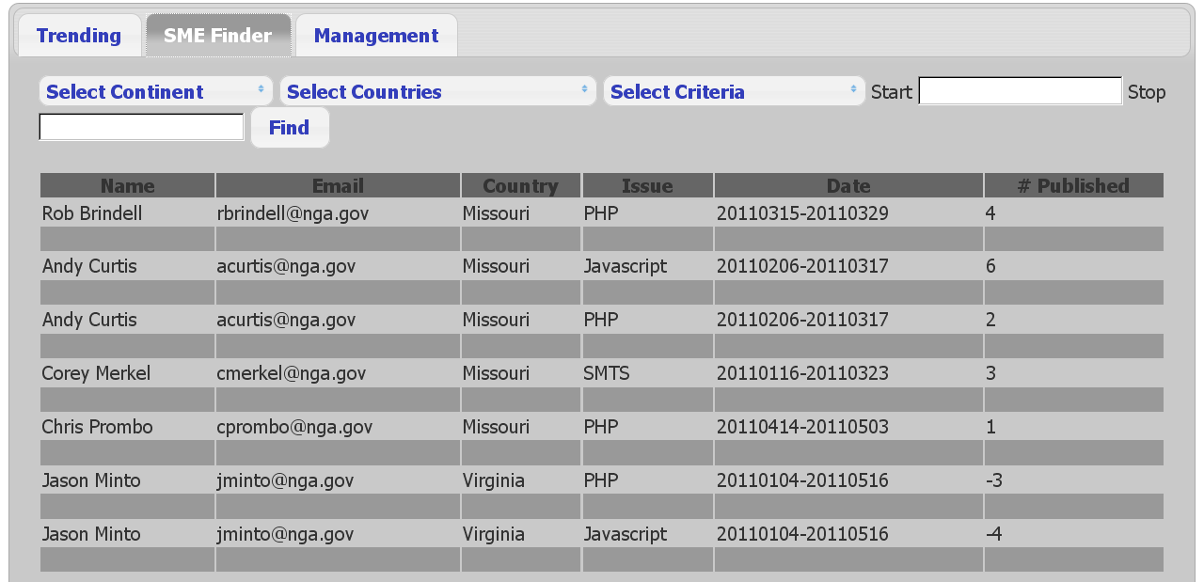

If you run into any further trouble with this widget, please email: xx@xx.com
Emails are typically responded to within 72 hours.

