1 December 2011

Style Guide and Multimedia Process Document

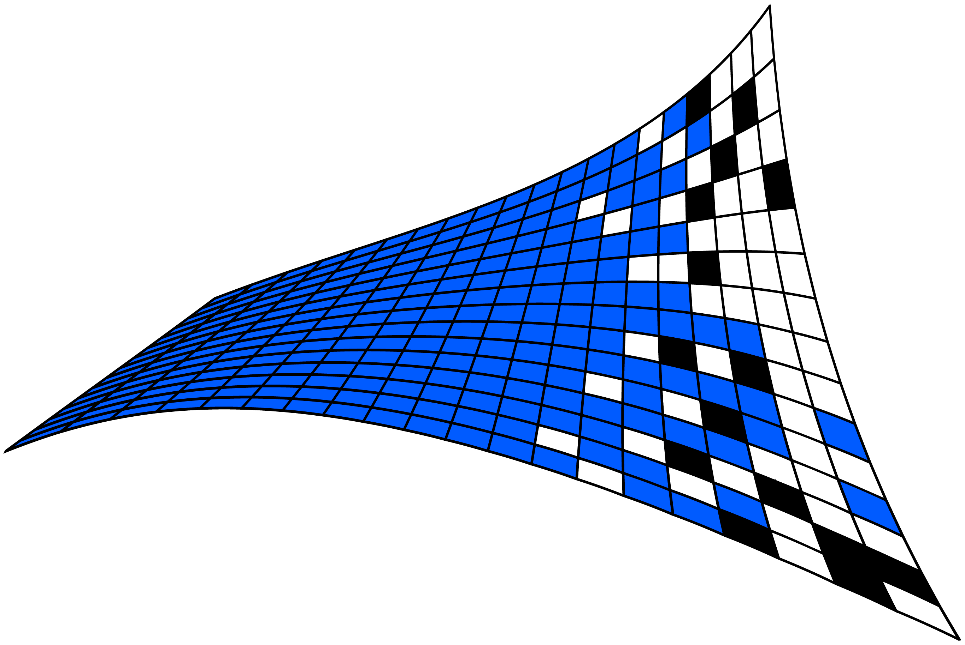

Change History
Version | Date of Change | Section(s) Changed | Summary of Change
- Updated Draft | - 12/1/2011 | - Initial document

Table of Contents
1. About This Document 4
1.1 Discovery Decision Support Toolkit System 4
1.2 Design Tools 4
2. Discovery Standards 5
2.1 DDST Logo 5
2.2 Short Discovery Logo 6
2.3 Unacceptable Use 7
2.4 Color Standards 8
2.5 Typeface Standards 9
2.6 Primary Typeface 9
2.7 Secondary Typeface 10
2.8 Animation Standards 10
3. Discovery Flash Launcher 13
4. Discovery Facilities Status Screen 14
5. Discovery Constellation Status Screen 15
6. Discovery Widget Selector 16

- About This Document
Welcome to the Discovery Decision Support Toolkit Style Guide. This document provides developers and anyone involved with the Discovery project to have guidelines on the front-end design of the Discovery COP System. The Discovery graphic design was designed with the following principles in mind:
- Scalability: Vector Graphics that will allow the system to be displayed on a 3” small mobile device or as large as the largest NOC screen (80’).
- Consistency in Branding and Design: Consistent Color Schemes, fonts, graphics headers and footers.
- Focus on the User Experience: Aesthetic Front end design and usability was considered from the beginning of the project all the way to the end.
- Branding: The Discovery logo and 3D Animation was designed based on the Discovery Shuttle program and concept feedback that we received from Fred Kemp.
  - Discovery System
The Discovery System is comprised of 8 Visual/Design ‘Products’. Those are defined as follows:
- Channel Launcher
- Constellation Visualization
- Discovery and Know logos
- Discovery Launcher
- Facilities Visualization
- Maya 3D and Discovery Animations
- Widget Launcher
- OWF Widgets
  - Design Tools
Design tools used in the Discovery front-end design work are as follows:
- Adobe Photoshop CS5
- Adobe Flash CS5
- Adobe Media Encoder CS5
- Adobe Fireworks CS5
- Adobe Premiere CS5
- Adobe Illustrator CS5
- Adobe Dreamweaver CS5
- Autodesk Maya 2010 (3D Modeling and Animation Tool)
This Guide will walk you through the creative assets and what standards were used in creating those assets in regards to logo use, color, typeface and animation so that said design can be taken over and worked with in a consistent manner moving forward.
- Discovery Standards
  - DDST Logo
Tools used: Adobe Photoshop CS5, Maya 2010
The logo mark has been developed for the Discovery COP System, as depicted in Figure 1, Figure 2, and Figure 3. The logo was designed to symbolize both the flexibility of the distribution of COP data as well as the multi-status/screen nature of the project. There are several variations of the Discovery logo but they are used within the COP system with either a white or black background. The tagline for the Discovery System is: To Know. Now.
Figure 1 -- DDST Logo
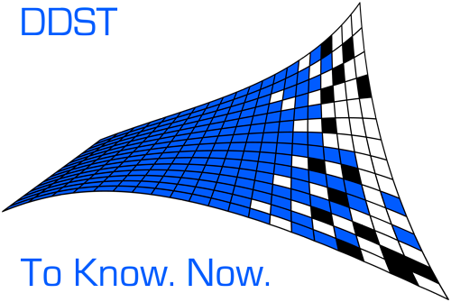

  - Short Discovery Logo
The logos are meant to be displayed in a standard square ratio as seen in the 3 figures below and not to be stretched.
Figure 2 – Standard One
Figure 3 -- Standard Two
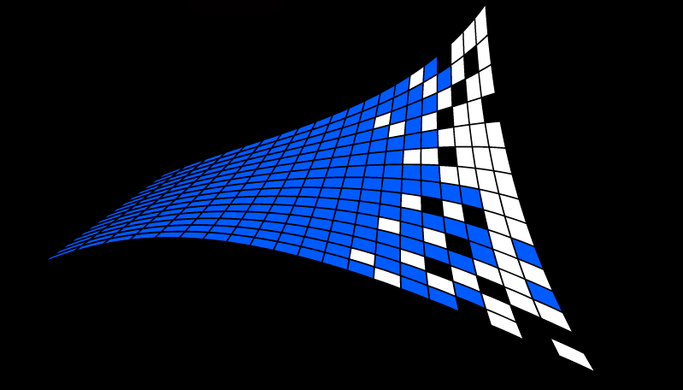
Figure 4 – Old Discovery Logos
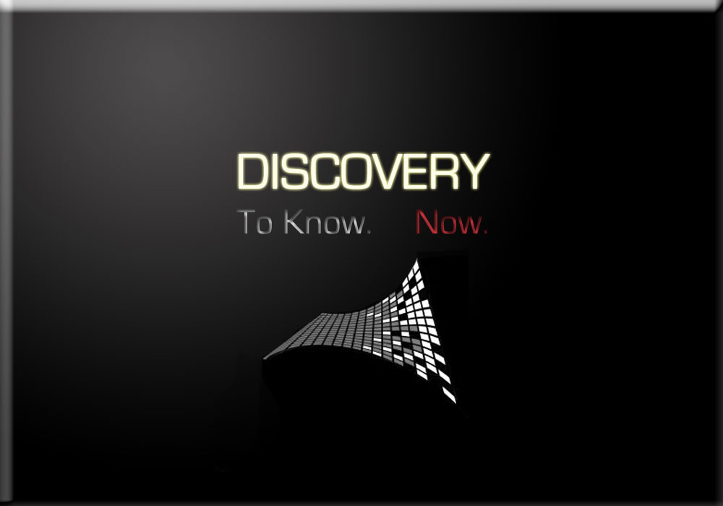
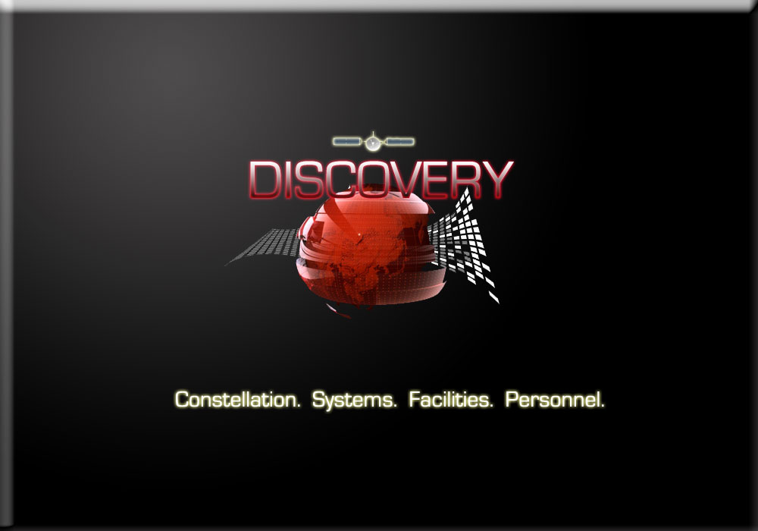
Old Discovery Condensed
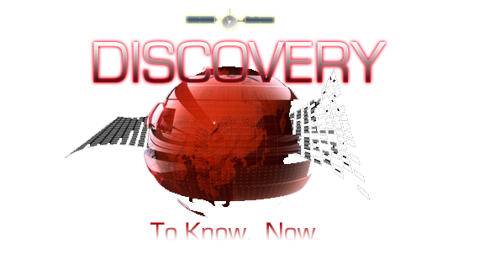

Any of these versions may be used. Use your best discretion as to the background color you would put these over to ensure contrast between the logo and the background color.
  - Unacceptable Use
The following conditions are not acceptable uses or alterations of the Discovery logo:
- Condensing, extending, skewing, distorting, manipulating, modifying, or redrawing the logo in any way
- Printing type or other elements inside the logo
- Altering the proportional relationships or the vertical and horizontal alignment of the elements of the logo (such as the example below)
- Placing the logo over areas of imagery where the logo is not clearly defined
Figure 7 -- Unacceptable Logo Usage
Official Seal to be used:

  - Color Standards
Tools Used: Adobe Photoshop CS5, Adobe Fireworks
We have standardized a color palette to ensure the consistency across the visual products of the Discovery Brand. Used consistently over time, colors become associated with organizations. Consistent use of the Discovery color palette will make the Discovery Project more recognizable and uniform across the organization. It will also provide a strong link across a wide range of applications that are created in the future across the organization. We only used ‘web safe colors’ in our design.
The Colors used in the Discovery Logo and Animation are presented in the tables below.
Table 1 – Discovery Logo Colors
Logo
DDST Logo Blue RBG Code | R-0 G - 91 B-255
OWF Widget Color Scheme (from UWP)
Grey | R-173 G-174 B-176
Dark Blue | R-56 G-72 B-99
Light Blue | R-83 G-121 B-160
Gold | R-156 G-130 B-47

Table 2 – General Animation and Widget Launcher Colors
General Flash Animation and Widget Launcher
Yellow Text Hex Code | FFFF00
White Text: Hex Code | FFFFFF
Red Text Hex Code | CC0000
Grey Bar Hex Code | CCCCCC

Table 3 – Icon Slider Colors
Icon Slider
Empty Icon (Photoshop Style)
Branded Icon
First Set of Icons Used:
The Appropriate use of these Icons in OWF are 64 x 64.
Improper use of these icons:
Alternative Icons 64 x 64 OWF Icons:
Table 4 – Status Icon Colors
Status Icon
Dark Blue Hex Code | 003366
Media Launch Background Hex Code | 0033ff
  - Typeface Standards
Tools Used: Adobe Photoshop CS5
When used carefully and consistently, typography can be a powerful tool that can help us to create a constant and credible brand style. Eurostile has been chosen as the font throughout the Discovery System because the font is modern, futuristic looking and readable. For actual website data – we have used Tahoma. For internal communications, presentations and related websites to the Discovery System – Century Gothic or Tahoma may be used a substitute font. No other typefaces, no matter how similar they appear, may be used.
  - Primary Typeface
EUROSTILE REGULAR
Abcdefghijklmnopqrstuvwxyz
123456789$%
EUROSTILE BOLD
Abcdefghijklmnopqrstuvwxyz
123456789$%
  - Secondary Typeface
Tahoma Regular
Abcdefghijklmnopqrstuvwxyz
123456789$%
Tahoma Bold
abcdefghijklmnopqrstuvwxyz
123456789$%
Tahoma Italic
abcdefghijklmnopqrstuvwxyz
123456789$%
  - Animation Standards
Tools Used: Adobe Photoshop CS5, Autodesk Maya 2010, Adobe Media Encoder, Adobe Premiere
The Discovery Loader Animations were built, textured, lit, camerad, animated and rendered out in Autodesk Maya. The render output file is a jpeg (example below) at 1024 x 768. The renders were rendered out using the Mental Ray render in Maya with These frames are edited in post-production via Adobe Premiere and then compressed down 16x their original size in Adobe Media Encoder. The final output is an FLV (Flash video file). The final animation is done at 29.97FPS (frames per second) and is 12 seconds in duration. There are sample renders below.
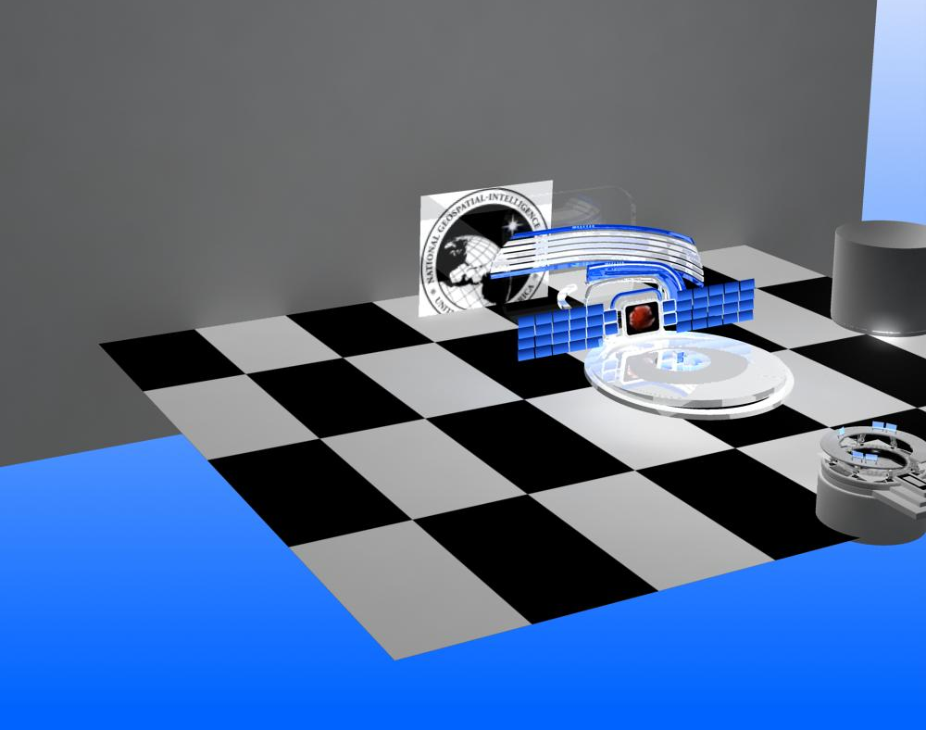
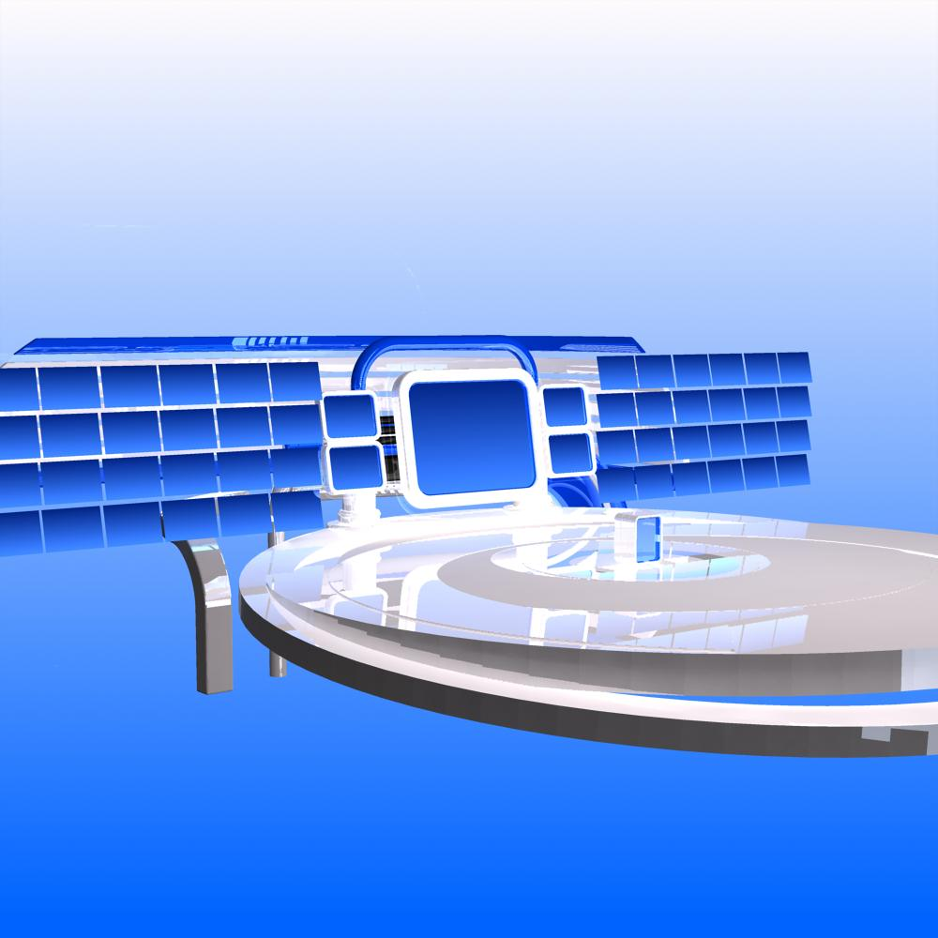

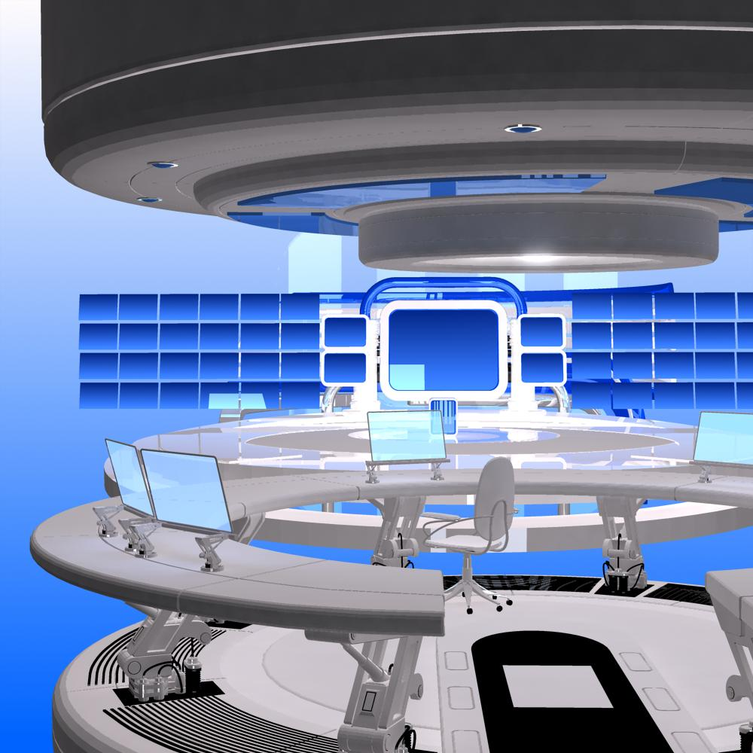

Figure 9 -- Animation Rendering (Step 2)
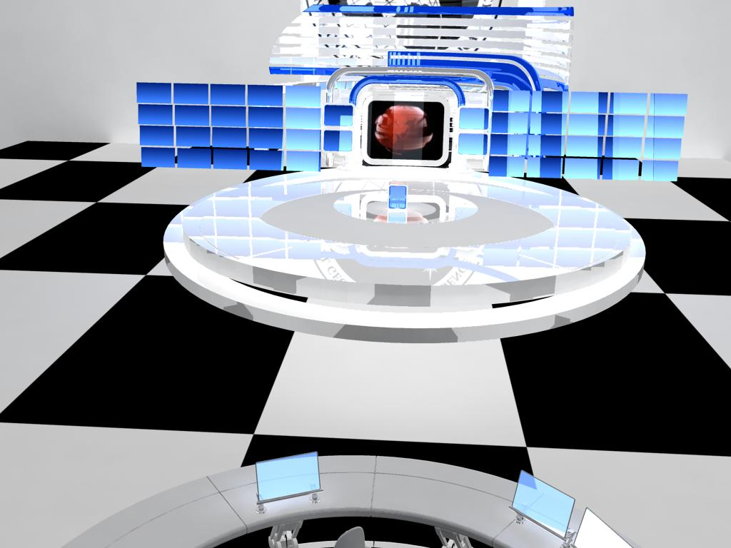

Figure 10 -- Animation Rendering (Step 3)
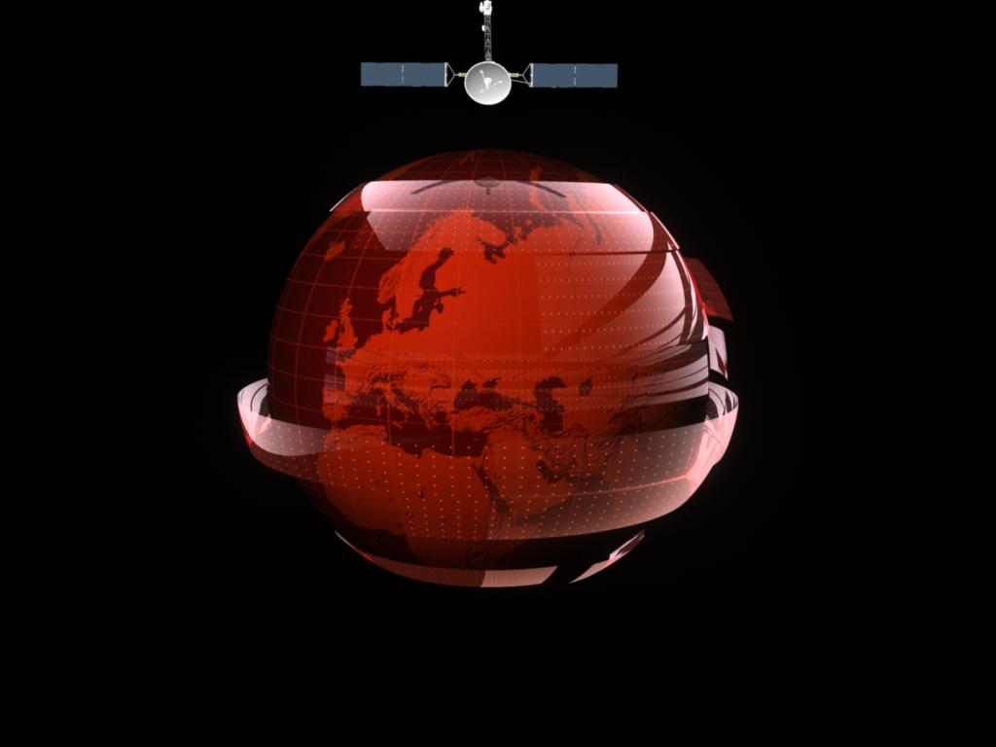

Figure 11 -- Animation Rendering (Step 4)

- Discovery Flash Launcher
The Discovery Flash Launcher, depicted Figure 12 in below, is an interface that allows those NOC personnel who are authorized to view and analyze the near-real-time statuses of Constellation, Facilities, Personnel and System. This interface was built in Flash to be scalable size wise for any screen size it is presented on. Users can launch and view individual statuses off of this view. This launcher was created in Flash CS5 which includes Actionscript 2 movie actions/controls such as ‘Get URL, GotoandPlay, LoadScene, Stop’. This Flash file was also published out in Flash Player 10 at 100% Screensize control. All of the animation, navigation, and text were created in Flash CS5 using vector graphics. The icons and layout graphic design was done in Photoshop CS5 and imported into Flash.
Figure 12 -
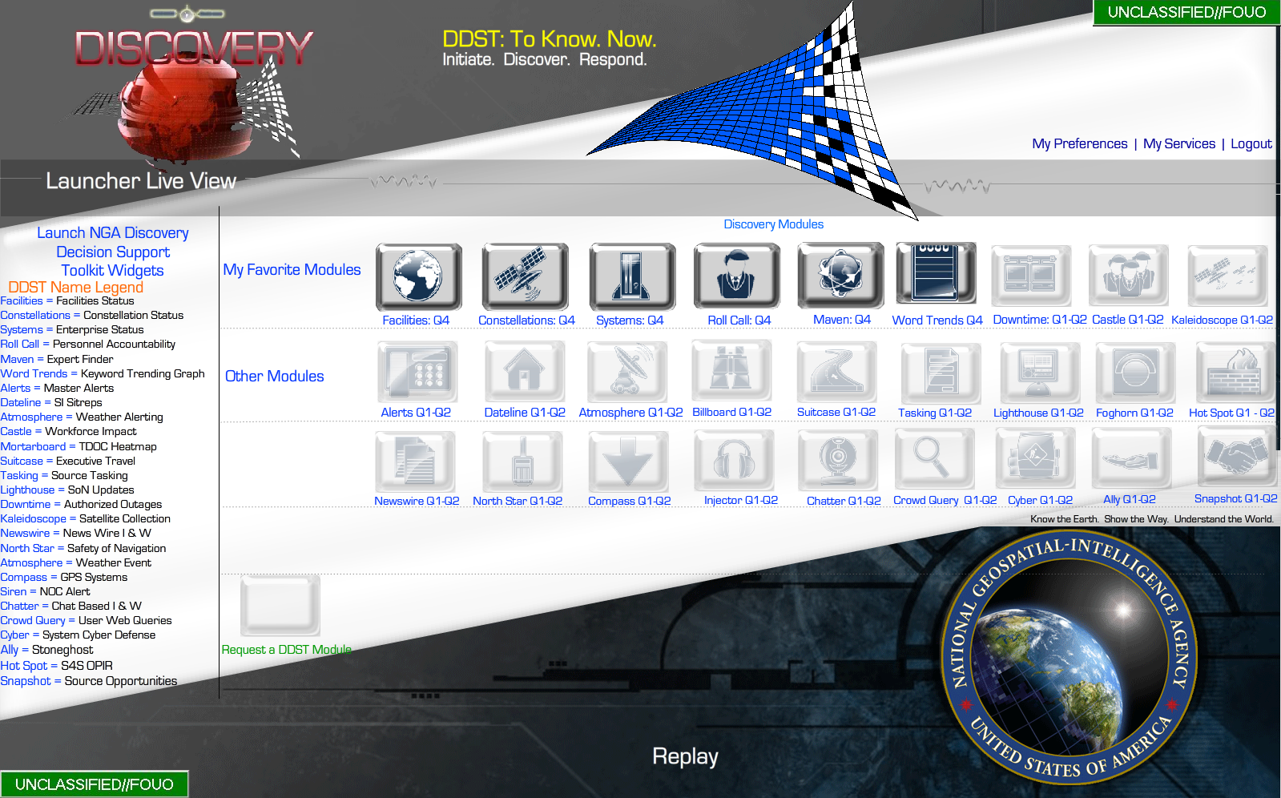

- Discovery OWF Widget Selector
The Discovery OWF Widget Selector, illustrated in 13 below, allows the user to view all of the available statuses and then to choose each one and customize their view based on a ‘widget view’. Widgets are resizable from very small to full screen and several can be interspersed together on the screen. The Widget launcher was created with a mix of HTML, Photoshop graphics, PHP code and Jquery UI containers that are the widgets holders.
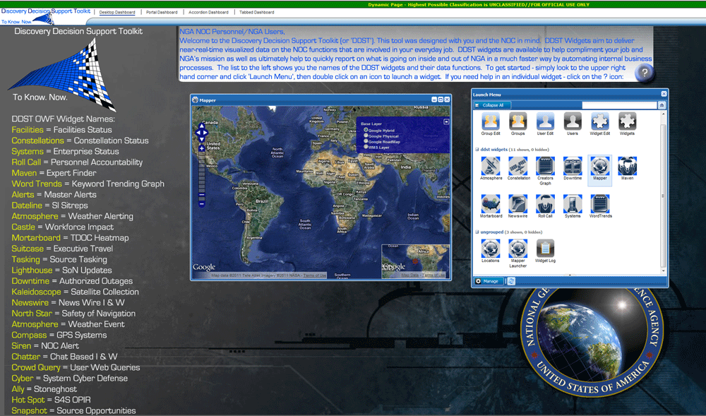

This background should be used behind every widget if you are displaying the widget on top of an HTML page.
Figure 13 – OWF Background
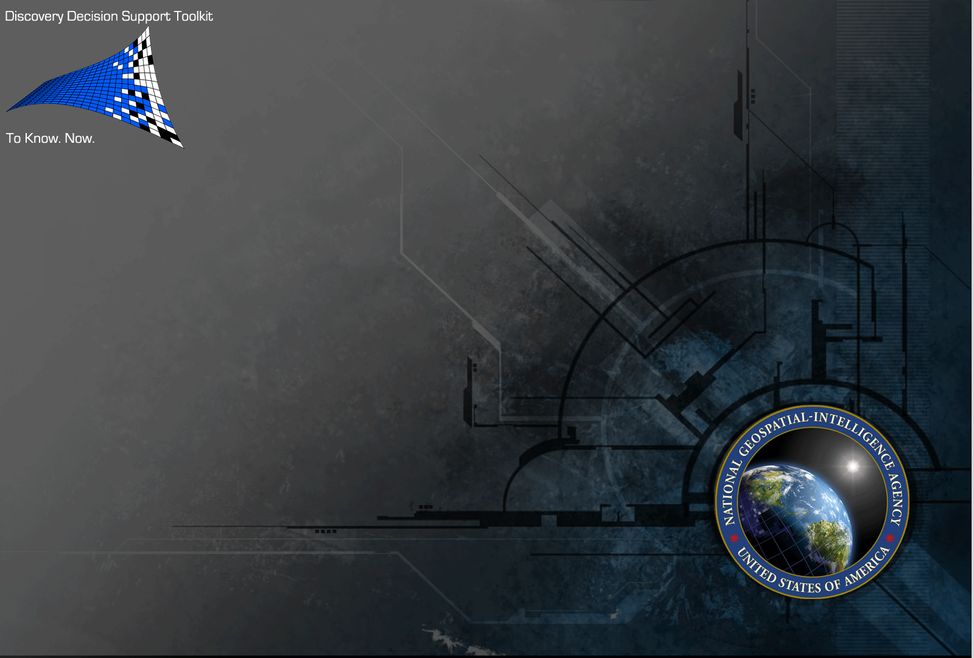
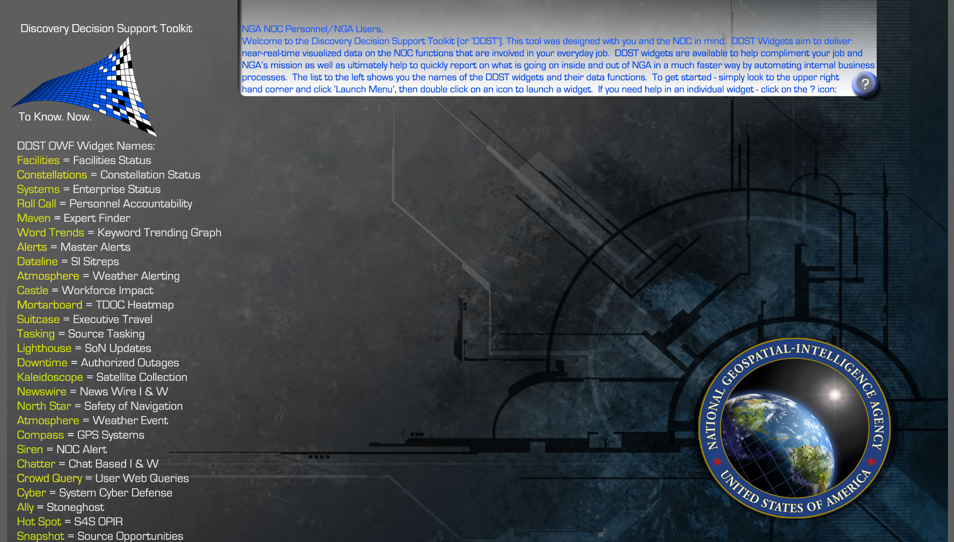

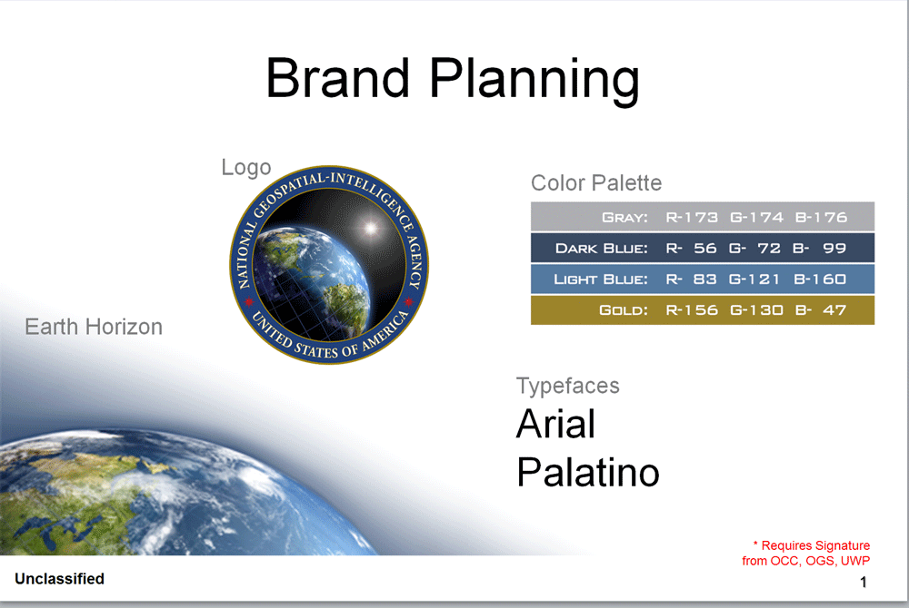
- Discovery Facilities Status Screen
The Constellation cascading style sheet information can be found in Table 6 below.
Table 5 – Facilities CSS Information
CSS File Name | constellation2.css
Font Family | Tahoma
Font Size | 18pt
Font Weight | Bold
Font Color | #009
Background Color | #333

The Constellation CSS sheet will appear as illustrated in Figure 13 below.
Figure 13 -- Facilities CSS Applied
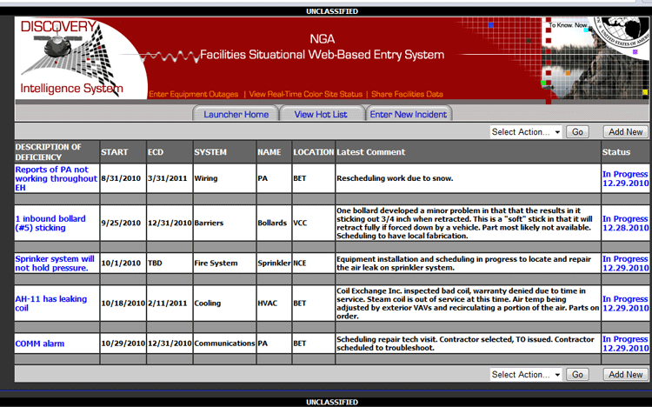

- Discovery Constellation Status Screen
The Constellation cascading style sheet (CSS) information can be found in Table 6 below.
Table 6 – Constellation CSS Information
CSS File Name | facilities2.css
Font Family | Tahoma
Font Size | 18pt
Font Weight | Bold
Font Color | #009
Background Color | #333

The Constellation CSS sheet will appear as illustrated in Figure 14 below.
Figure 14 -- Constellation CSS Applied
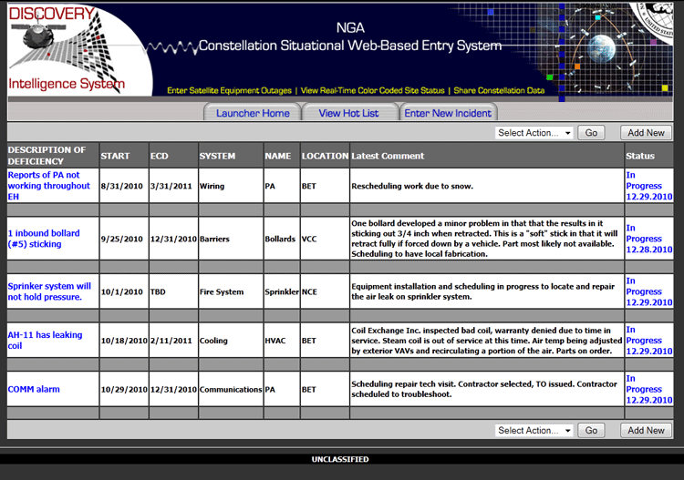

Authorized Outages Visualization

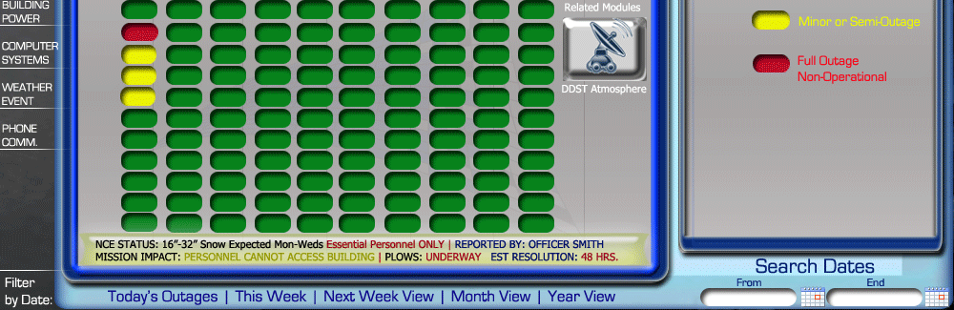
Constellation Visualization
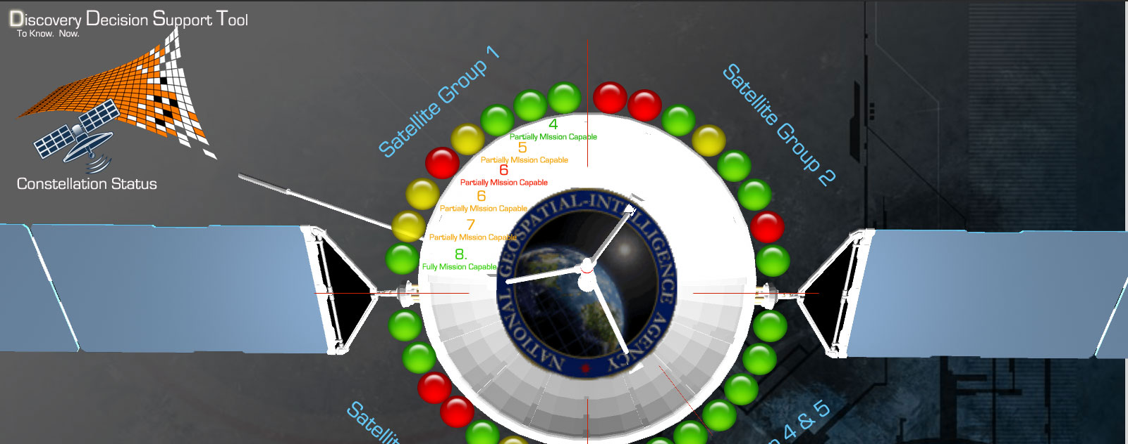
DDST Mapper Widget
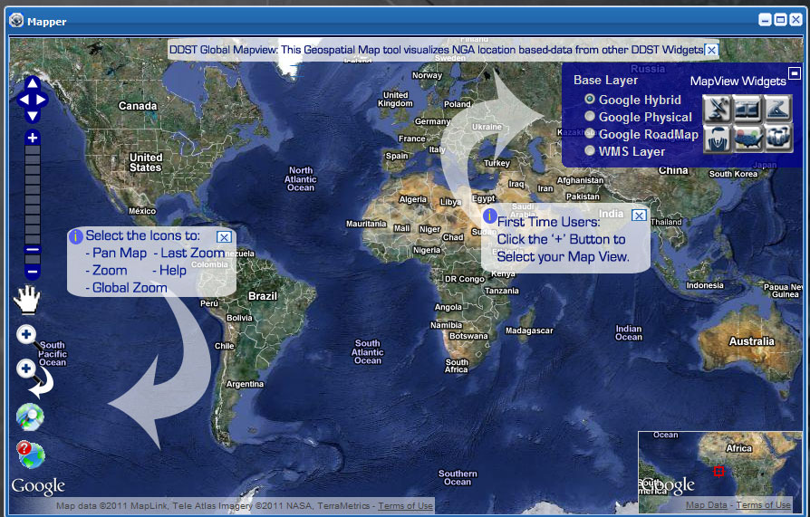
DDST Keyword Widget
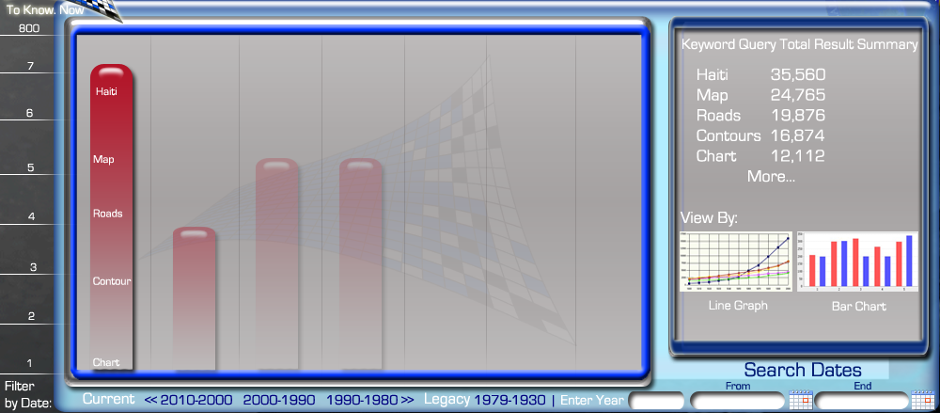
DDST Systems Widget

Any questions regarding this report should be addressed to:

Andrew Weyrich

